МІНІСТЕРСТВО ОСВІТИ І НАУКИ УКРАЇНИ
Національний аерокосмічний університет ім. М.Є. Жуковського
“Харківський авіаційний інститут”

Кафедра комп’ютерних систем, мереж і кібербезпеки (503)

Лабораторна робота № 6

з дисципліни “WEB-програмування”

Изучение структуры XML файлов

ХАІ.503.535Б.19О. 050102, 1705047

Виконав студент гр. 535Б Климов В.С.
(№ групи) (П.І.Б.)

(підпис, дата)
Перевірив доцент каф. 503
(науковий ступінь, вчене звання, посада)
Морозова О.І.
(підпис, дата) (П.І.Б.)

2019

Задание на лабораторную работу №6

Цель:
Изучение структуры XML файлов. Изучение возможностей языка серверных сценариев - PHP. Ознакомление с возможностями языка PHP для обработки XML файлов.

Постановка задачи:
Требуется создать XML документ, хранящий информацию о товарах какого-либо типа (например: мобильные телефоны, компьютеры, автомобили и т.д.).
- Информация о каждом из товаров должна содержать:
- Наименование товара
- Цена товара
- Серийный номер товара
- Год выпуска
- Имя файла, представляющего картинку данного товара
- И два-три параметра, специфических для данного типа товаров
Полученный XML файл наполнить данными на 10-15 товаров.

Инструментальные средства:
В качестве языка программирования серверных сценариев обязательно должен быть использован язык PHP.

Для формирования кода могут быть использованы следующие программные пакеты
- Блокнот (Notepad.exe)
- PHP Expert Editor
- Home Site
- И любые другие аналогичные пакеты

При создании скрипта каталога потребуются следующие функции:
- xml_parser_create
- xml_parser_set_option
- xml_set_element_handler
- xml_set_character_data_handler
- xml_parse
- xml_error_string
- xml_get_error_code
- xml_get_current_line_number
- xml_parser_free

Дополнительная информация по работе с XML документами может быть найдена в Руководстве по PHP в разделе XML parser functions.

Варианты заданий
Вариант | Функция | Комментарии
1 | Создать XML файл с DTD определением структуры. Написать скрипт разбора XML файла. | В качестве примера могут быть использованы XML файлы со старыми заданиями на лабораторные работы, находящиеся в папке с текущими заданиями.

Часть 2. HTML и CSS файлы для решения задачи

Файл - index.html

<!DOCTYPE html>
<html>
<head>
<meta charset="utf-8" />
<title>Климов В.С.</title>
<script type="text/javascript" src="scripts/animation.js"></script>
<script type="text/javascript" src="scripts/script.js"></script>
<link rel="stylesheet" href="styles/style.css" />
</head>
<body onload="return animate();">
<div id="canvas">
<header>
<!--<img src="" alt="Header" />-->
<div id="headRef"><a href="index.html">www.spttowndirty.com</a></div>
</header>
<main>
<!--<span id="underheaderline" class="textColor hText">best records music cds singers albums hits tracks spt-towndirty sound music best records music cds singers albums hits tracks spt-towndirty</span>-->
<div id="menu" class="hText">
<ul>
<li>best records</li>
<li>music</li>
<li>cds</li>
<li>singers</li>
<li>albums</li>
<li>hits</li>
<li>tracks</li>
<li>spt-towndirty</li>
<li>sound</li>
</ul>
</div>
<div class="wrap-content">
<div class="col1">
<ul id="list">
<li><a href="index.html">about us</a></li>
<li><a href="redirect.html">music</a></li>
<li><a href="form.html">info-cds</a></li>
<li><a href="">contacts</a></li>
<li><a href="">records</a></li>
<li><a href="">news</a></li>
</ul>
</div>
<div class="col2">
<div>
<div class="text textColor">
<img class="content-img-r" src="images/img1.jpg" alt="img1">
Everybody always asking "When you guys getting online?". It took a
minute due to our busy schedule but we finally got it together and made
it happen. We are happy with the new projects we got lined up for the
new Year so check with our tour dates and news sections as our
schedules continue to pile up. The “Artists” section will feature samples
of each of our artists’ cuts from their up and coming albums. Our street
team program is definitely something to look into as you can earn money by becoming part of
our street team. Click the link for more info. T-Shirts, hats, clothes, sun visors… something for
the ladies as well as the men. We got it all so check out the merchandise link.
</div>
<div class="text textColor">
<img class="content-img-l" src="images/img2.jpg" alt="img2">
Our street team program is definitely something to look into as you can
earn money by becoming part of our street team. Click the link for more
info. T-Shirts, hats, clothes, sun visors… something for the ladies as
well as the men. We got it all so check out the merchandise link. Don't
forget to get what you originally came for. Check out and order one or
more of our cd's. Oh yeah Dj's get at us. If you a up and coming DJ
and ready to make some loot get at us by contacting us at the link on
the left. Everybody always asking "When you guys getting online?". It took a minute due
to our busy schedule but we finally got it together and made it happen. We are happy
with the new projects we got lined up for the new Year so check with our tour dates
and news sections as our schedules continue to pile up.
</div>
<div class="text textColor">
<img class="content-img-r" src="images/img3.jpg" alt="img3">
Everybody always asking "When you guys getting online?". It took a
minute due to our busy schedule but we finally got it together and made
it happen. We are happy with the new projects we got lined up for the
new Year so check with our tour dates and news sections as our
schedules continue to pile up. The “Artists” section will feature samples
of each of our artists’ cuts from their up and coming albums. Our street
team program is definitely something to look into as you can earn money by becoming part of
our street team. Click the link for more info. T-Shirts, hats, clothes, sun visors… something for
the ladies as well as the men. We got it all so check out the merchandise link.
</div>
</div>
</div>
<div id="animated"></div>
<div id="animated1"></div>
</div>
</main>
</div>
</body>
</html>

Файл – form.html
<!DOCTYPE html>
<html>
<head>
<meta charset="utf-8" />
<title>Климов В.С.</title>
<script type="text/javascript" src="scripts/animation.js"></script>
<script type="text/javascript" src="scripts/script.js"></script>
<link rel="stylesheet" href="styles/style.css" />
</head>
<body onload="return animate();">
<div id="canvas">
<header>
<!--<img src="" alt="Header" />-->
<a href="index.html"><div id="headRef">www.spttowndirty.com</div></a>
</header>
<main>
<!--<span id="underheaderline" class="textColor hText">best records music cds singers albums hits tracks spt-towndirty sound music best records music cds singers albums hits tracks spt-towndirty</span>-->
<div id="menu" class="hText">
<ul>
<li>best records</li>
<li>music</li>
<li>cds</li>
<li>singers</li>
<li>albums</li>
<li>hits</li>
<li>tracks</li>
<li>spt-towndirty</li>
<li>sound</li>
</ul>
</div>
<div class="wrap-content">
<div class="col1">
<ul id="list">
<li><a href="index.html">about us</a></li>
<li><a href="redirect.html">music</a></li>
<li><a href="form.html">info-cds</a></li>
<li><a href="">contacts</a></li>
<li><a href="">records</a></li>
<li><a href="">news</a></li>
</ul>
</div>
<div class="col2">
<form action="index.html" onsubmit="return validateForm()">
<table>
<tr>
<td>Name:</td>
<td class="formElem"><input type="text" id="Name" oninput="validate()" placeholder="Name" /></td>
<td id="NameErr" class="err"></td>
</tr>
<tr>
<td>Surname:</td>
<td class="formElem"><input type="text" id="Surname" oninput="validate()" placeholder="Surname" /></td>
<td id="SurnameErr" class="err"></td>
</tr>
<tr>
<td>Patronymic:</td>
<td class="formElem"><input type="text" id="Patronymic" oninput="validate()" placeholder="Patronymic" /></td>
<td id="PatronymicErr" class="err"></td>
</tr>
<tr>
<td>Age:</td>
<td title="Choose your age." class="formElem clear">
<select>
<option value="1">under 16</option>
<option value="2">16-21</option>
<option value="3">21-27</option>
<option value="4">27-35</option>
<option value="5">35-45</option>
<option value="6">45-55</option>
<option value="7">above 55</option>
</select>
</td>
<td></td>
</tr>
<tr>
<td id="about">About you:</td>
<td class="formElem clear"><textarea cols="25" id="About" rows="10" placeholder="about me" oninput="validateTA()"></textarea></td>
<td id="AboutErr" class="err"></td>
</tr>
<tr>
<td></td>
<td class="formElem clear"><input id="submitButton" type="submit" value="submit" /></td>
<td></td>
</tr>
</table>
</form>
</div>
<div id="animated"></div>
<div id="animated1"></div>
</div>
</main>
</div>
</body>
</html>

Файл redirect.html
<!DOCTYPE html>
<html>
<head>
<meta charset="utf-8" />
<title>Климов В.С.</title>
<script type="text/javascript" src="scripts/animation.js"></script>
<script type="text/javascript" src="scripts/script.js"></script>
<script type="text/javascript" src="scripts/redirect.js"></script>
<link rel="stylesheet" href="styles/style.css" />
</head>
<body onload="return animate();">
<div id="canvas">
<header>
<!--<img src="" alt="Header" />-->
<a href="index.html"><div id="headRef">www.spttowndirty.com</div></a>
</header>
<main>
<!--<span id="underheaderline" class="textColor hText">best records music cds singers albums hits tracks spt-towndirty sound music best records music cds singers albums hits tracks spt-towndirty</span>-->
<div id="menu" class="hText">
<ul id="list">
<li>best records</li>
<li>music</li>
<li>cds</li>
<li>singers</li>
<li>albums</li>
<li>hits</li>
<li>tracks</li>
<li>spt-towndirty</li>
<li>sound</li>
</ul>
</div>
<div class="wrap-content">
<div class="col1">
<ul id="list">
<li><a href="index.html">about us</a></li>
<li><a href="redirect.html">music</a></li>
<li><a href="form.html">info-cds</a></li>
<li><a href="">contacts</a></li>
<li><a href="">records</a></li>
<li><a href="">news</a></li>
</ul>
</div>
<div class="col2">
<div id="redirSpan">Redirect in 3 (sec)</div>
</div>
<div id="animated"></div>
<div id="animated1"></div>
</div>
</main>
</div>
</body>
</html>

Файл – Laba_1.css

@font-face {
font-family: B52; /* ��� ������ */
src: url(../fonts/B52.woff); /* ���� � ����� �� ������� */
}
body {
margin: 0;
background-color: black;
font: normal 12px Arial;
color: white;
}
#canvas {
width: 780px;
margin: 0 auto;
}
header {
background-image: url(../images/Header.jpg);
height: 128px;
}
#headRef {
padding-left: 90px;
padding-top: 90px;
font: normal 30px B52;
}
header img {
vertical-align: bottom;
}
#underheaderline{
margin-left: 5px;
margin-bottom: 10px;
}
main {
/*height: 470px;*/
background-image: url(../images/Disk.jpg);
/*background-position: right;*/
background-position-x: right;
background-position-y: 20px;
background-repeat: no-repeat;
}
/*main:after {
content: "";
clear: both;
float: none;
display: block;
}*/
#menu ul {
margin: -5px 0 5px;
padding: 0;
text-align: center;
text-transform: uppercase;
}
.clearfix {
clear: both;
float: none;
}
#menu ul li {
display: inline-block;
padding: 5px;
text-decoration: none;
text-align: center;
list-style: none;
color: white;
}
#menu li:hover {
background-color: #990033;
color: Tomato
}
.textColor {
color: white;
}
.hText {
font: 7pt B52;
font-weight: bold;
}
#disk{
float:right;
}
.text {
font: normal 12px Arial;
line-height: 1.5;
margin-bottom: 20px;
}
.col1 {
float: left;
width: 20%;
background-image: url(../images/stics.png);
background-position: top left;
background-repeat: no-repeat;
margin: 0 1.5%;
background-size: 100% 100%;
}
#list {
list-style-type: none;
margin: 0;
padding: 7px 0px 3px 0px;
text-transform: uppercase;
}
#list a {
padding: 6px 0 7px;
margin-bottom: 8px;
}
a {
color:white;
display: block;
text-decoration: unset;
}
#list li {
/*padding: 6px 0 14px;*/
text-align: center;
}
.col2 {
float: left;
width: 65%;
}
#animated {
left: 690px;
position: absolute;
height: 400px;
width: 80px;
float: left;
background-image: url(../images/DiskText1.png);
background-repeat: no-repeat;
background-position-y: -350px;
}
#animated1 {
left: 690px;
position: absolute;
height: 400px;
width: 80px;
float: left;
background-image: url(../images/steam.png);
background-repeat: no-repeat;
background-position-y: -350px;
background-position-x: 15px;
}
.content-img-r {
float: right;
padding: 0 0 0 8px;
}
.content-img-l {
float: left;
padding: 0 8px 0 0;
}
.wrap-content {
position: relative;
font: 10pt B52;
}
.wrap-content:after {
display: block;
clear: both;
float: none;
content: "";
}
#submitButton {
width: 80px;
height: 30px;
}
.formElem {
/*height: 5%;
width:33%;
float: left;
margin: 10px;*/
font: normal 10px Arial;
}
.err:after{
clear: both;
float: none;
}
span:after {
clear: both;
float: none;
}
.err {
width: 50%;
/*float: left;
margin: 10px;*/
color: red;
font: normal 12px Arial;
}
#redirSpan {
margin: 200px 100px 200px 200px;
font-size: 16px;
}
input {
background-color: gray;
border: 2px solid #404040;
height: 25px;
width: 160px;
color: white;
border-radius: 5px;
}
textarea {
background-color: gray;
border: 2px #404040 solid;
color: white;
width: 160px;
height: 130px;
border-radius: 5px;
}
::-webkit-input-placeholder { /* Chrome/Opera/Safari */
color: #ff6a00;
}
select {
background-color: gray;
height: 31px;
width: 100px;
border: 2px solid #404040;
color: white;
border-radius: 5px;
}
.clear {
content: "";
display: block;
float:none;
clear:both;
}
td {
padding-top:10px;
}
#about {
vertical-align:top;
}
table {
margin-bottom: 60px;
width: 100%;
}

Файл animation.js
; function animate(duration) {
var element = document.getElementById("animated");
var fps = 60;
var x1 = -350;
var x2 = 0;
//var positionY = 0;//-350;
var duration = 3000.0;
//var k = 1 / duration;
var t0 = new Date();//skolko
var intervalID = setInterval(frame, 1000.0 / fps);
function frame() {
var elp = new Date();//10
var delta = elp.getTime() - t0.getTime();
var k = delta / duration;
var coord;
if (k > 1) {
k = 1;
coord = func(k);
element.style.backgroundPositionY = coord + "px";
clearInterval(intervalID);
animate1(1);
}
else {
coord = func(k);
element.style.backgroundPositionY= coord + "px";
}
};
; function func(k) {
return x = x1 + (x2 - x1) * (Math.sqrt(k));
}
};
; function animate1(duration) {
var element = document.getElementById("animated1");
var fps = 60;
var x1 = -400;
var x2 = 0;
//var positionY = 0;//-350;
var t = 1500.0;
//var k = 1 / duration;
var t0 = new Date();
var intervalID = setInterval(frame, 1000.0 / fps);
function frame() {
var elp = new Date();
var delta = elp.getTime() - t0.getTime();
var k = delta / t;
var coord;
if (k > 1) {
k = 1;
coord = func(k);
element.style.backgroundPositionY = coord + "px";
clearInterval(intervalID);
}
else {
coord = func(k);
element.style.backgroundPositionY = coord + "px";
}
};
; function func(k) {
return x = x1 + (x2 - x1) * (Math.sqrt(k));
}
};

redirect.js
document.onload = red();
;function red(){
var clock = 3;
var t1 = setInterval(function () {
var text = document.getElementById("redirSpan");
clock--;
if (clock == -1) {
clearInterval(t1);
location.href = "index.php";
}
else {
text.innerHTML = "Redirect in " + clock + " (sec)";
}
}, 1000);
}

script.js
; function validateForm() {
var Name = document.getElementById("Name");
var Surname = document.getElementById("Surname");
var Patronymic = document.getElementById("Patronymic");
var NameErr = document.getElementById("NameErr");
var SurnameErr = document.getElementById("SurnameErr");
var PatronymicErr = document.getElementById("PatronymicErr");
var About = document.getElementById("About");
var AboutErr = document.getElementById("AboutErr");
// var
var text = Name.value;
var validMessage = "*Only A-Z, a-z symbols allow."
//sreturn false;
var validName = validateString(text);
if (!validName) {
NameErr.textContent = validMessage;
} else {
NameErr.textContent = null;
}
text = Surname.value;
var validSurn = validateString(text);
if (!validSurn) {
valid2 = false;
SurnameErr.textContent = validMessage;
} else {
SurnameErr.textContent = null;
}
text = Patronymic.value;
var validPart = validateString(text);
if (!validPart) {
PatronymicErr.textContent = validMessage;
} else {
PatronymicErr.textContent = null;
}
text = About.value;
var validTextAr = validateTextarea(text)
if (!validTextAr) {
AboutErr.textContent = validMessage;
} else {
AboutErr.textContent = null;
}
return validName && validSurn && validPart && validTextAr;
}
; function validate() {
//alert('asd');
var text = event.target.value;
var target = event.target;
//alert(text);
if (text == "" || text == null) {
event.target.style.border = "2px solid grey";
}
else {
var isValid = true;
var textLen = text.length;
text = text.trim();
if (!text.match(/^[a-z\s]+$/i)) {
isValid = false;
}
if (isValid) {
target.style.border = "2px solid green";
} else {
target.style.border = "2px solid red";
}
}
}
; function validateString(string) {
var reg = /^[a-z\s]+$/i;
string = string.trim();
return reg.test(string);
};
; function validateTextarea(string) {
var reg = /^[A-Za-z\d\s\.,]+$/;
string = string.trim();
return reg.test(string);
}
; function validateTA() {
//alert('asd');
var text = event.target.value;
var target = event.target;
//alert(text);
if (text == "" || text == null) {
event.target.style.border = "2px solid grey";
}
else {
var isValid = true;
var textLen = text.length;
text = text.trim();
if (!text.match(/^([A-Za-z\d\s\.,]+)$/)) {
isValid = false;
}
if (isValid) {
target.style.border = "2px solid green";
} else {
target.style.border = "2px solid red";
}
}
}

footer.php
</div>
<div id="animated"></div>
<div id="animated1"></div>
</div>
</main>
</div>
</body>
</html>

Form.php
<?php require('header.php');?>
<div id ="div_text">
<div class ="text_main">
<form action="validate.php" method="post" onsubmit="return validateForm()">
<div>
<div id="sur_div">Surname:</div>
<div class="form_input"><input type="text" name="surname" placeholder="Surname" id="surname"/></div>
<div id="error_surname"></div>
</div>
<div class="form_clear">
<div><br>Name:</div>
<div class="form_input"><input type="text" name="Name" placeholder="Name" id="Name" /></div>
<div id="error_Name"></div>
</div>
<div class="form_clear">
<div><br>Patron:</div>
<div class="form_input"><input type="text" name="Patronymic" placeholder="Patron" id="Patronymic" /></div>
<div id="error_Patronymic"></div>
</div>
<div class="form_clear">
<div><br>Your old:</div>
<div><select name="select" placeholder="select" id="select">
<option value="1">Below 16</option>
<option value="2">16-21</option>
<option value="3">21-27</option>
<option value="4">27-35</option>
<option value="5">35-45</option>
<option value="6">45-55</option>
<option value="7">Under 55</option>
</select></div>
</div>
<div><br><input type="submit" name="submit" value="submit" /></div>
</form>
</div>
</div>
<?php require('footer.php');?>

header.php

<!DOCTYPE html>
<html>
<head>
<meta charset="utf-8" />
<title>Климов В.С.</title>
<script type="text/javascript" src="scripts/animation.js"></script>
<!-- <script type="text/javascript" src="scripts/script.js"></script>-->
<link rel="stylesheet" href="styles/style.css" />
</head>
<body onload="return animate();">
<div id="canvas">
<header>
<!--<img src="" alt="Header" />-->
<div id="headRef"><a href="index.html">www.spttowndirty.com</a></div>
</header>
<main>
<!--<span id="underheaderline" class="textColor hText">best records music cds singers albums hits tracks spt-towndirty sound music best records music cds singers albums hits tracks spt-towndirty</span>-->
<div id="menu" class="hText">
<ul>
<li>best records</li>
<li>music</li>
<li>cds</li>
<li>singers</li>
<li>albums</li>
<li>hits</li>
<li>tracks</li>
<li>spt-towndirty</li>
<li>sound</li>
</ul>
</div>
<div class="wrap-content">
<div class="col1">
<ul id="list">
<li><a href="index.php">about us</a></li>
<li><a href="redirect.php">music</a></li>
<li><a href="Form.php">info-cds</a></li>
<li><a href="server_info.php">contacts</a></li>
<li><a href="file_system.php">records</a></li>
<li><a href="magazine.php">news</a></li>
</ul>
</div>
<div class="col2">

index.php
<?php require('header.php');?>
<div>
<div class="text textColor">
<img class="content-img-r" src="images/img1.jpg" alt="img1">
Everybody always asking "When you guys getting online?". It took a
minute due to our busy schedule but we finally got it together and made
it happen. We are happy with the new projects we got lined up for the
new Year so check with our tour dates and news sections as our
schedules continue to pile up. The “Artists” section will feature samples
of each of our artists’ cuts from their up and coming albums. Our street
team program is definitely something to look into as you can earn money by becoming part of
our street team. Click the link for more info. T-Shirts, hats, clothes, sun visors… something for
the ladies as well as the men. We got it all so check out the merchandise link.
</div>
<div class="text textColor">
<img class="content-img-l" src="images/img2.jpg" alt="img2">
Our street team program is definitely something to look into as you can
earn money by becoming part of our street team. Click the link for more
info. T-Shirts, hats, clothes, sun visors… something for the ladies as
well as the men. We got it all so check out the merchandise link. Don't
forget to get what you originally came for. Check out and order one or
more of our cd's. Oh yeah Dj's get at us. If you a up and coming DJ
and ready to make some loot get at us by contacting us at the link on
the left. Everybody always asking "When you guys getting online?". It took a minute due
to our busy schedule but we finally got it together and made it happen. We are happy
with the new projects we got lined up for the new Year so check with our tour dates
and news sections as our schedules continue to pile up.
</div>
<div class="text textColor">
<img class="content-img-r" src="images/img3.jpg" alt="img3">
Everybody always asking "When you guys getting online?". It took a
minute due to our busy schedule but we finally got it together and made
it happen. We are happy with the new projects we got lined up for the
new Year so check with our tour dates and news sections as our
schedules continue to pile up. The “Artists” section will feature samples
of each of our artists’ cuts from their up and coming albums. Our street
team program is definitely something to look into as you can earn money by becoming part of
our street team. Click the link for more info. T-Shirts, hats, clothes, sun visors… something for
the ladies as well as the men. We got it all so check out the merchandise link.
</div>
</div>
<?php require('footer.php');?>

redirect.php
<?php require('header.php');?>
<script type="text/javascript" src="scripts/redirect.js"></script>
<div id="redirSpan">Redirect in 3 (sec)</div>
<?php require('footer.php');?>

server_info.php

<?php require('header.php');?>
<?php require('server_vars.php');?>
<?php require('footer.php');?>

server_vars.php
<div style="overflow-x: scroll; width: 500px;">
<div>
<p style="color: green">$_SERVER</p>
<?php
foreach($_SERVER as $key=>$var){
echo "<p>$key = $var<P>";
echo "<hr/>";
}
echo "<br/>";
echo "<hr/>";
?>
</div>
<div >
<p style="color: green">$_GET</p>
<?php
foreach($_GET as $key=>$var){
echo "<p>$key = $var<P>";
echo "<hr/>";
}
echo "<br/>";
echo "<hr/>";
?>
</div>
<div >
<p style="color: green">$_POST</p>
<?php
foreach($_POST as $key=>$var){
echo "<p>$key = $var<P>";
echo "<hr/>";
}
echo "<br/>";
echo "<hr/>";
?>
</div>
</div>

validate.php
<?php require('header.php');?>
<?php
function valiadte($name, $surname, $patronymic, $about)
{
$name = trim($name);
$surname = trim($surname);
$patronymic = trim($patronymic);
$about = trim($about);
$isSuccessed = Array(false, false, false, false);
$isSuccessed[0] = preg_match("/^[a-z\s]+$/i",$name);
$isSuccessed[1] = preg_match("/^[a-z\s]+$/i",$surname);
$isSuccessed[2] = preg_match("/^[a-z\s]+$/i",$patronymic);
$isSuccessed[3] = preg_match("/^[a-z\s]+$/i",$about);
$res = true;
foreach ($isSuccessed as $isSucc)
{
$res = $res && $isSucc;
}
if($res)
{
echo "<p style='color: green;'>SUCCESS</p>";
}
else{
echo "<p style='color: red;'>ERROR</p>";
}
if(preg_match("/^[a-z\s]+$/i",$name)){
echo "<p>neme - DONE</p>";
}
else{
echo "<p>NEME - ERR</p>";
}
if(preg_match("/^[a-z\s]+$/i",$surname)){
echo "<p>surname - DONE</p>";
}
else{
echo "<p>surname - ERR</p>";
}
if(preg_match("/^[a-z\s]+$/i",$patronymic))
{echo "<p>patronymic - DONE</p>";}
else{
echo "<p>patronymic - ERR</p>";
}
if(preg_match("/^[a-z\d\s\.,]+$/i",$about))
{echo "<p>about - DONE</p>";}
else{
echo "<p>about - ERR</p>";
}
};
$action = "";
if(isset($_GET['formact']))
{
$action = "GET";
}elseif (isset($_POST['formact']))
{
$action = "POST";
}
switch ($action)
{
case "GET":
valiadte($_GET['Name'],$_GET['Surname'], $_GET['Patronymic'], $_GET['About']); break;
case "POST":
valiadte($_POST['Name'],$_POST['Surname'], $_POST['Patronymic'], $_POST['About']); break;
}
/* echo "".$_POST['formact']."";
if(isset($_POST['Name']))
{
echo "POST";
}
if(isset($_GET['Name']))
{
echo "GET";
}*/
?>
<?php require('footer.php');?>
file_system.php
<?php
require('header.php');
// Get all files from current directory or use path from GET
function get_dir_files() {
$dir_path = __DIR__;
$skip_back = true;
if (!empty($_GET['path']) && file_exists($_GET['path']) && strpos($_GET['path'], __DIR__) !== false && strpos($_GET['path'], '/..') === false) {
if ($_GET['path'] != __DIR__) {
$dir_path = $_GET['path'];
$skip_back = false;
}
}
$dir_files = scandir($dir_path);
$files = [];
foreach ($dir_files as $file) {
if ($file == '.' || ($skip_back && $file == '..')) continue;
$path = $dir_path . '/' . $file;
$info = get_info($path, $file);
$files[] = [
'name' => $info['name'],
'path' => $info['path'],
'type' => $info['type'],
'size' => $info['size'],
'date' => $info['date'],
];
}
sort_files($files);
return $files;
}
// Generate file info
function get_info($path, $filename) {
$type = 'directory';
$size = '-';
$name = $filename;
$dir_path = '';
if (is_dir($path)) {
$dir_path = '<a href="?path='. realpath($path) .'">'. $filename .'</a>';
} else {
$type = 'file';
$size = filesize($path);
}
return [
'name' => $name,
'path' => $dir_path,
'type' => $type,
'size' => $size,
'date' => filemtime($path),
];
}
// Get correct file size name
function file_size_convert($bytes)
{
$bytes = floatval($bytes);
$arBytes = array(
0 => array(
"UNIT" => "TB",
"VALUE" => pow(1024, 4)
),
1 => array(
"UNIT" => "GB",
"VALUE" => pow(1024, 3)
),
2 => array(
"UNIT" => "MB",
"VALUE" => pow(1024, 2)
),
3 => array(
"UNIT" => "KB",
"VALUE" => 1024
),
4 => array(
"UNIT" => "B",
"VALUE" => 1
),
);
foreach($arBytes as $arItem)
{
if($bytes >= $arItem["VALUE"])
{
$result = $bytes / $arItem["VALUE"];
$result = str_replace(".", "," , strval(round($result, 2)))." ".$arItem["UNIT"];
break;
}
}
return $result;
}
// Sorting function
function sort_files(&$files) {
if (empty($_GET['sort'])) return;
$sort_type = !empty($_GET['sort_type']) ? $_GET['sort_type'] : 'asc';
foreach ($_GET['sort'] as $sort) {
usort($files, function ($a, $b) use ($sort, $sort_type) {
if ($sort == 'name') {
if ($sort_type == 'desc') {
return - strcasecmp($a[$sort], $b[$sort]);
}
return strcasecmp($a[$sort], $b[$sort]);
}
if ($a[$sort] == $b[$sort]) {
return 0;
}
if ($sort_type == 'desc') {
return ($a[$sort] > $b[$sort]) ? -1 : 1;
}
return ($a[$sort] < $b[$sort]) ? -1 : 1;
});
}
}
// Created HTML for files result
function print_files() {
$files = get_dir_files();
if (empty($files)) {
echo 'There are no files in this directory';
return;
}
$html = '<table class="file-system-table">
<tr>
<th>Имя</th>
<th>Тип</th>
<th>Размер</th>
<th>Дата создания</th>
</tr>';
foreach ($files as $file) {
$html .= '<tr>
<td>'. ($file["path"] ?: $file["name"]) .'</td>
<td>'. $file["type"] .'</td>
<td>'. file_size_convert($file["size"]) .'</td>
<td>'. date('d-m-Y H:s:i', $file["date"]) .'</td>
</tr>';
}
$html .= '</table>';
return $html;
}
// Created GET query for sorting
function buildSortQuery($type) {
$data = $_GET;
if (!empty($data['sort']) && in_array($type, $data['sort'])) {
unset($data['sort'][array_search($type, $data['sort'])]);
} else {
$data['sort'][] = $type;
}
return http_build_query($data);
}
// Created GET query for sorting type
function buildSortTypeQuery($type) {
$data = $_GET;
if (!empty($data['sort_type'])) {
unset($data['sort_type']);
}
$data['sort_type'] = $type;
return http_build_query($data);
}
?>
<div class="sorting">
<a href="?<?= buildSortQuery('date'); ?>" <?= (isset($_GET['sort']) && in_array('date', $_GET['sort'])) ? 'style="color:green;"' : ''; ?>>дата создания</a>
<a href="?<?= buildSortQuery('name'); ?>" <?= (isset($_GET['sort']) && in_array('name', $_GET['sort'])) ? 'style="color:green;"' : ''; ?>>имя</a>
<a href="?<?= buildSortQuery('size'); ?>" <?= (isset($_GET['sort']) && in_array('size', $_GET['sort'])) ? 'style="color:green;"' : ''; ?>>размер</a>
<a href="?<?= buildSortTypeQuery('asc'); ?>" <?= (!isset($_GET['sort_type']) || $_GET['sort_type'] == 'asc') ? 'style="color:green;"' : ''; ?>>ASC</a>
<a href="?<?= buildSortTypeQuery('desc'); ?>" <?= (isset($_GET['sort_type']) && $_GET['sort_type'] =='desc') ? 'style="color:green;"' : ''; ?>>DESC</a>
</div>
<div class="file-table">
<?= print_files(); ?>
</div>
<? require('footer.php'); ?>

magazine.php
<?php
require_once ('header.php');
require_once ('XMLparse.php');
$products = getProducts();
?>
<div class="magazine">
<div class="wrapper">
<?php foreach ($products as $product) : ?>
<div class="product clear-both">
<div class="product-thumb">
<img class="thumbnail" alt="product-thumb" src="<?= $product["IMAGE"] ?>"/>
</div>
<div class="info">
<span class="product-name"><?= $product["NAME"] ?></span>
<span class="product-model"><?= $product["MODEL"] ?></span>
<table>
<tr>
<td>Display:</td>
<td><?= $product["DISPLAY"] ?></td>
</tr>
<tr>
<td>Year:</td>
<td><?= $product["PROD_YEAR"] ?></td>
</tr>
<tr>
<td>CPU:</td>
<td><?= $product["CPU"] ?></td>
</tr>
<tr>
<td>Serial number:</td>
<td><?= $product["SERIAL_NUMBER"] ?></td>
</tr>
</table>
</div>
<div class="price">
<span>Цена: <?= $product["PRICE"] ?> ₴</span>
</div>
</div>
<?php endforeach; ?>
</div>
</div>
<?php require_once ('footer.php'); ?>

XMLparse.php

<?php
$products = array();
$product = array();
$currentTeg = "";
function getProducts() {
global $products, $product;
$parser=xml_parser_create();
xml_set_element_handler($parser,"start","stop");
xml_set_character_data_handler($parser,"char");
$fp=fopen("xml/shop.xml","r");
while ($data=fread($fp,4096)){
xml_parse($parser,$data,feof($fp)) or
die (sprintf("XML Error: %s at line %d",
xml_error_string(xml_get_error_code($parser)),
xml_get_current_line_number($parser)));
}
xml_parser_free($parser);
return $products;
}
function start($parser, $elem, $element_attrs){
global $product,$currentTeg;
switch($elem){
case "ITEM":
$product["NAME"] = $element_attrs["NAME"];
break;
case "DISPLAY":
$currentTeg = "DISPLAY";
break;
case "IMAGE":
$currentTeg = "IMAGE";
break;
case "ITEMS":
break;
default:
$product[$elem] = $element_attrs["VALUE"];
break;
}
}
function stop($parser, $element_name){
global $products,$product,$currentTeg;
if($element_name=="ITEM")
$products[] = $product;
$currentTeg= "";
}
function char($parser, $data){
global $product,$currentTeg;
if($currentTeg == "IMAGE" || $currentTeg == "DISPLAY")
$product[$currentTeg] = $data;
}
?>
shop.xml
<?xml version="1.0" encoding="utf-8"?>
<!DOCTYPE items SYSTEM "shop.dtd">
<items>
<item name="REDMI NOTE 8 PRO 6/64GB">
<model value="NOTE 8 PRO 6/64GB"></model>
<price value="5559"></price>
<cpu value="Mediatek Helio G90T"></cpu>
<serial_number value="56 218722"></serial_number>
<prod_year value="2019"></prod_year>
<display>6,53 (IPS)</display>
<image>https://avic.ua/assets/cache/images/assets/files/products/218722/image/450x400-redmi-note-8-pro-green.jpg</image>
</item>
<item name="SAMSUNG GALAXY NOTE 10 8/256GB">
<model value="NOTE 10"></model>
<price value="18539"></price>
<cpu value="Exynos 9825"></cpu>
<serial_number value="41 217872"></serial_number>
<prod_year value="2019"></prod_year>
<display>6,3 (Dynamic AMOLED)</display>
<image>https://avic.ua/assets/cache/images/assets/files/products/217872/image/450x400-samsung-galaxy-note-10-8-256gb-aura-glow-1.jpg</image>
</item>
<item name="XIAOMI REDMI 8 3/32GB">
<model value="REDMI 8 3/32GB"></model>
<price value="2999"></price>
<cpu value="Qualcomm Snapdragon 439"></cpu>
<serial_number value="41 218758"></serial_number>
<prod_year value="2019"></prod_year>
<display>6,22 (IPS)</display>
<image>https://avic.ua/assets/cache/images/assets/files/products/218758/image/450x400-redmi-8-ruby-red-1.jpg</image>
</item>
<item name="APPLE IPHONE X 64GB">
<model value="IPHONE X 64GB"></model>
<price value="19899"></price>
<cpu value="Apple A11 Bionic"></cpu>
<serial_number value="72 236234"></serial_number>
<prod_year value="2018"></prod_year>
<display>5,8 (Super Retina HD), OLED</display>
<image>https://avic.ua/assets/cache/images/assets/files/products/34378/image/450x400-apple-iphone-x-silver-01.jpg</image>
</item>
<item name="APPLE IPHONE 11 PRO MAX 64GB">
<model value="IPHONE 11 PRO MAX 64GB"></model>
<price value="30599 "></price>
<cpu value="Apple A13 Bionic"></cpu>
<serial_number value="56 218498"></serial_number>
<prod_year value="2019"></prod_year>
<display>6,5 (Super Retina XDR), OLED</display>
<image>https://avic.ua/assets/cache/images/assets/files/products/218498/image/450x400-apple-iphone-11-pro-max-space-gray-1.jpg</image>
</item>
<item name="APPLE IPHONE 8 64GB">
<model value="IPHONE 8 64GB"></model>
<price value="12450"></price>
<cpu value="Apple A11 Bionic"></cpu>
<serial_number value="01 034325"></serial_number>
<prod_year value="2017"></prod_year>
<display>4,7 (HD-дисплей Retina)</display>
<image>https://avic.ua/assets/cache/images/assets/files/products/34325/image/450x400-apple-iphone-8-gold-02.jpg</image>
</item>
</items>

shop.dtd

<!ELEMENT items (item*)>
<!ELEMENT item (model,display,price,cpu,serial_number,prod_year,image)
<!ELEMENT model EMPTY>
<!ELEMENT price EMPTY>
<!ELEMENT cpu EMPTY>
<!ELEMENT serial_number EMPTY>
<!ELEMENT prod_year EMPTY>
<!ATTLIST item name CDATA #REQUIRED>
<!ATTLIST model value NMTOKEN #REQUIRED>
<!ATTLIST price value NMTOKEN #REQUIRED>
<!ATTLIST cpu value NMTOKEN #REQUIRED>
<!ATTLIST serial_number value NMTOKEN #REQUIRED>
<!ATTLIST prod_year value NMTOKEN #REQUIRED>
<!ELEMENT display (#PCDATA)>
<!ELEMENT image (#PCDATA)>
>

Часть 3. Картинка полученного результата
Полученная гипертекстовая страница с использованием языка HTML, а также таблиц стилей CSS продемонстрированная на рис. 2

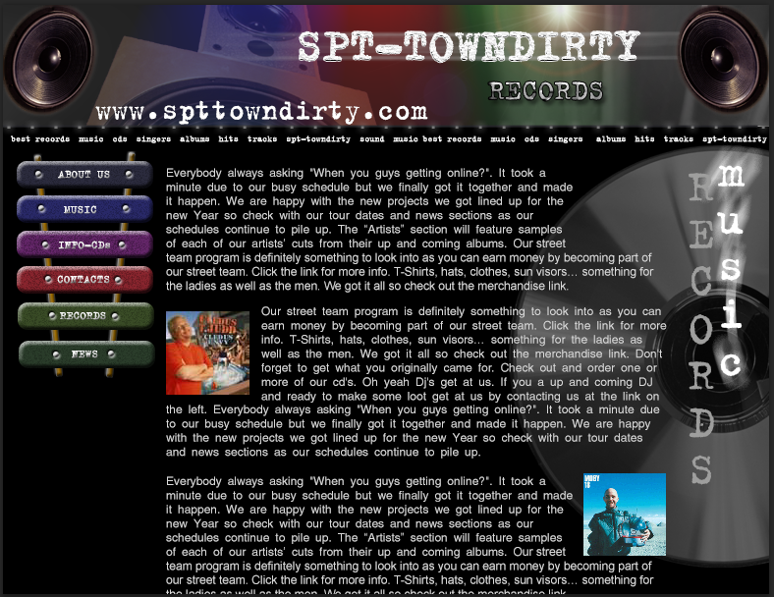

Рис. 2
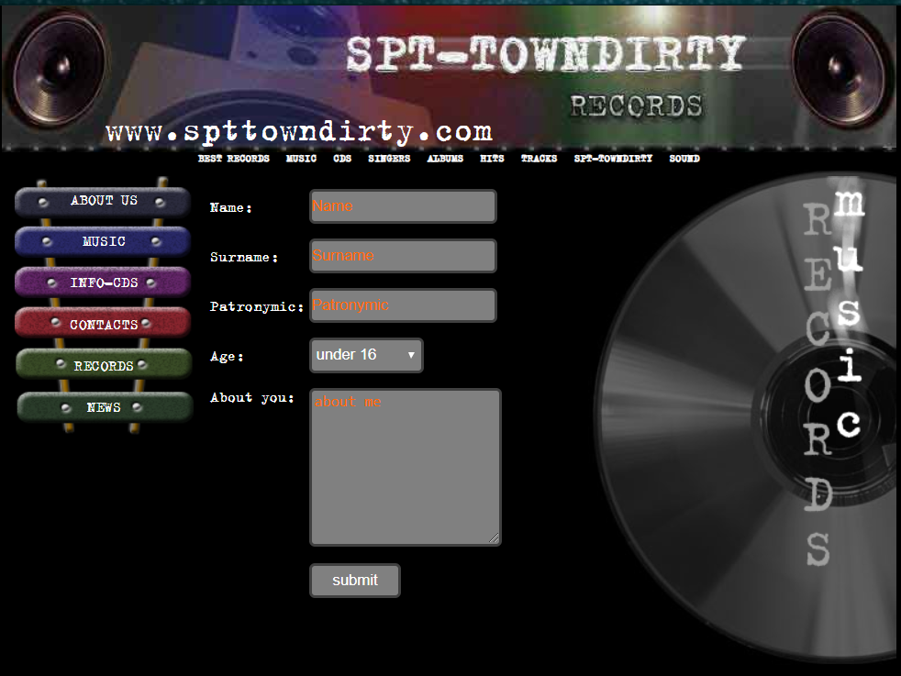
Рис 3

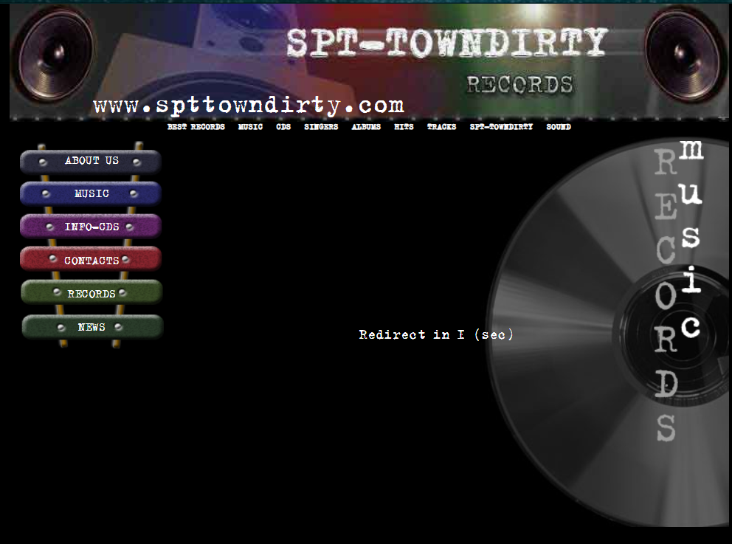
Рис 4
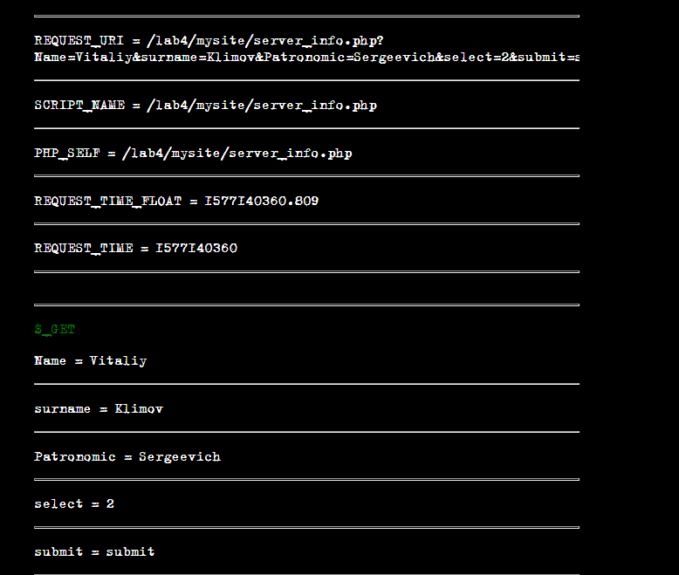
Рис 5

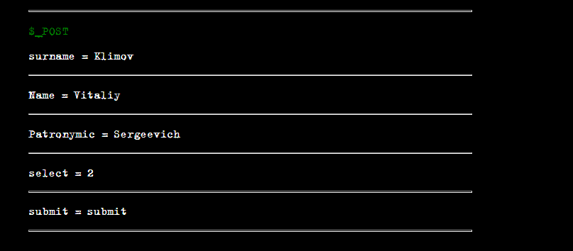

Рис6

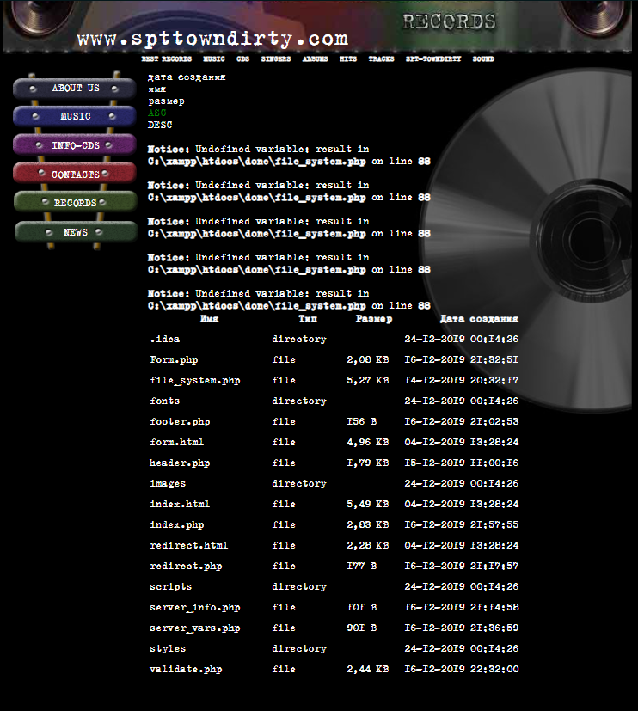
Рис7

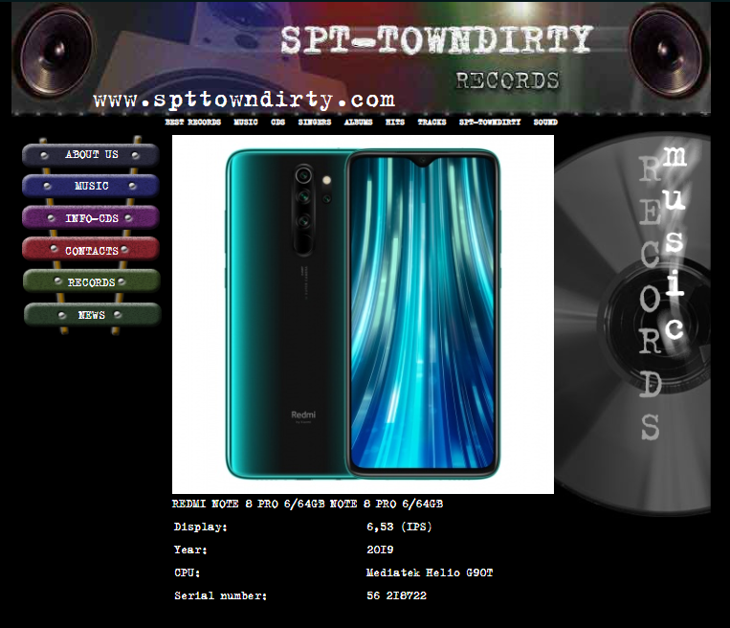
Рис8

Выводы
В результате выполнения лабораторной работы была разработана гипертекстовая страница с использованием языка HTML, а также таблиц стилей CSS. Научился использовать глобальные и локальные включения, работать с основными тегами и свойствами а также писать java-скрипты.
Также изучил возможности языка серверных сценариев – PHP. Ознакомился с функциями навигации по файловой системе.
Изучил структуры XML файлов. Изучил возможности языка серверных сценариев - PHP. Ознакомился с возможностями языка PHP для обработки XML файлов.

